**The Big Picture Experience Partner Day - DigiPack FAQ**

If your question isn’t answered here please call 132 058, select option #2 events.

**Registration & DigiPack**

1. **What is the difference between *The Big Picture Experience – Partner Day (Day1)* and *The Big Picture Experience (Day2)*?**

The Sydney and Melbourne events are over two days. The Big Picture Experience – Partner Day (Day 1) is an event for Microsoft Partners only (that is; Gold, Silver, Action Pack or Subscriber Partners who are members of the Microsoft Partner Network). The Big Picture Experience (Day 2) is aimed at Microsoft commercial and public sector customers. The Audience on Day 2 can range from IT, business decision makers, to SMB business owners, to users of the technology in a large or medium size organisation. The content will vary over the two days with Partner Day content tailored specifically to meet Partner needs, and the Day two content tailored to large enterprise (am) to medium sized business (pm). Partners are welcome to host their customers on day two.

1. **I can’t register twice online. Can I host my customers at The Big Picture Experience (day two), as well as attend The Big Picture Partner Day?**

Yes, if you are planning to host your customers at Big Picture Experience Day two please email

[Events.Microsoft@jackmorton.com.au](mailto:Events.Microsoft@jackmorton.com.au) and a registration administrator will add this to your record.

1. **I can’t register twice online. I want to attend both Sydney and Melbourne, how do I register?**

Email [Events.Microsoft@jackmorton.com.au](mailto:Events.Microsoft@jackmorton.com.au) and a registration administrator will add this to your record.

1. **I didn’t receive a confirmation email, was my registration successful?**

You will not receive a confirmation email. Your registration was successful if:

1. After completing the registration form you were directed to a page titled “You are attending the Big Picture Experience”
2. You will also receive a reminder email and/or text message a few days before the event
3. You signed up for a DigiPack
4. **How can I cancel my registration for the event?**

Email [Events.Microsoft@jackmorton.com.au](mailto:Events.Microsoft@jackmorton.com.au) and a registration administrator will cancel your registration.

1. **How do I check whether I registered for the right event?**

Sign up for or sign into [Digi Pack](http://www.bigpicture.ms/) and click on My Event.

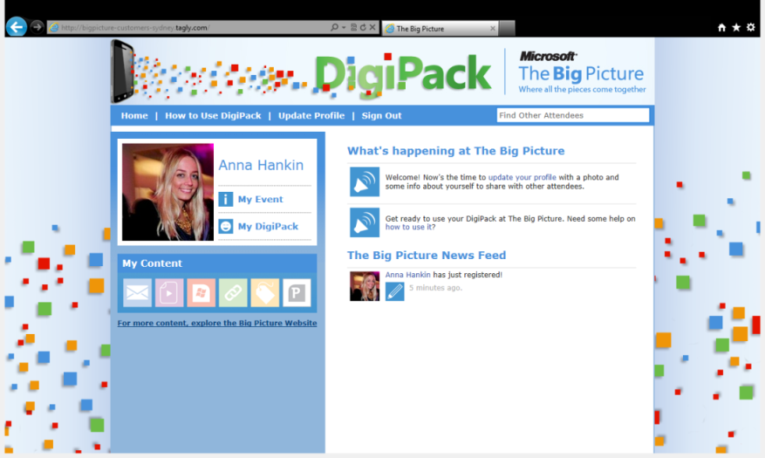

1. **What do I do if I registered for the wrong event?**

Email [Events.Microsoft@jackmorton.com.au](mailto:Events.Microsoft@jackmorton.com.au) and a registration administrator will amend your registration.

1. **I’m registered but don’t have a DigiPack? How do I get one?**

You can return at any time to www.bigpicture.ms to sign up for your DigiPack. Doing so before you arrive at the event will help you get the most from your visit.

1. **I signed up for DigiPack but didn’t receive the email to validate my email address and activate my DigiPack? What do I do?**

Firstly check your junk mail and then if you are still unable to locate it you can request another one requesting it from the verification page. If you still do not receive your email, please let us know at [support@tagly.com](mailto:support@tagly.com)

1. **I can only sign up for DigiPack – Partner Day, what if I am attending day two with my customers?**

The DigiPack on Partner Day is tailored to your interests. Any content relevant to you on Day two will be available at Partner Day so snap away and show your customers how to snap when you return the next day.

1. **How do I change my password?**

It’s possible to reset your password on the sign in screen. Use the Help! I forgot my password link under the Log box.

1. **I’ve forgotten my password. How do I reset it?**

It’s possible to reset your password on the sign in screen. Use the Help! I forgot my password link under the Log box.

1. **What information can I insert in my Biography**

You can insert any text information into your Bio. It is not possible to insert html or to embed an image into your Bio.

1. **What image formats can I use to upload my profile pic?**

You can upload an image that is GIF, PNG or JPG

1. **I’m already registered to attend the event and I’m trying to open a DigiPack but having issues.** If you are having issues setting up a DigiPack please email [support@tagly.com](mailto:support@tagly.com)
2. **How long will the DigiPack be open for?**

The Melbourne and Sydney DigiPacks will be active until the 13th of January, 2012

1. **How can I delete content from my DigiPack?**

It’s not possible to delete items from the DigiPack

1. **How do I close my DigiPack?**

No need, we will automatically delete it for you when the DigiPack closes on 13 January, 2012

1. **I don’t have a smartphone. How will I access my DigiPack and will I be able to snap content?**

That’s easy. You can add items to your DigiPack on the Desktop version of the DigiPack. The content will be active to add from morning of the event.

1. **How do I make sure others can’t see my DigiPack profile?**

It’s easy to change your privacy preferences. Once inside your DigiPack select Update Profile. Check the option box under your profile and save your profile.

**Agenda, meals, Wi-Fi and other questions:**

1. **What time should I arrive?**

Check in and doors open at 8.00am – from this time so you can explore the showcase, grab a coffee and chat with the Microsoft team. The Keynote presentation starts at 9.00am, followed by a series of sessions and talks throughout the day.

1. **What time does it finish?**

The day will wrap up at 5.00pm

1. **Do I need to attend the whole day?**

No. The day will be jam packed with valuable sessions and talks but you can check in at any time to explore the showcase.

1. **Will food and coffee be provided?**

Food and coffee will be provided throughout the day. There will be scheduled breaks so you can grab a bite to eat, explore the showcase and chat to the Microsoft team without missing out on any sessions and talks.

1. **Will I have access to complimentary Wi-Fi?**

Both the Sydney Convention and Exhibition Centre and Melbourne Convention and Exhibition Centre offer their visitors complimentary Wi-Fi. Microsoft cannot guarantee the speed or bandwidth of this network.

1. **How do I find Microsoft product specialists and sales teams?**

Visit Meet Microsoft located in the centre of the showcase. Whether you know who you’re looking for or simply have questions that need answering, a friendly Microsoft team member will put you in touch with the right person.

1. **Other questions:**

Call 132 058, select option #2 events.